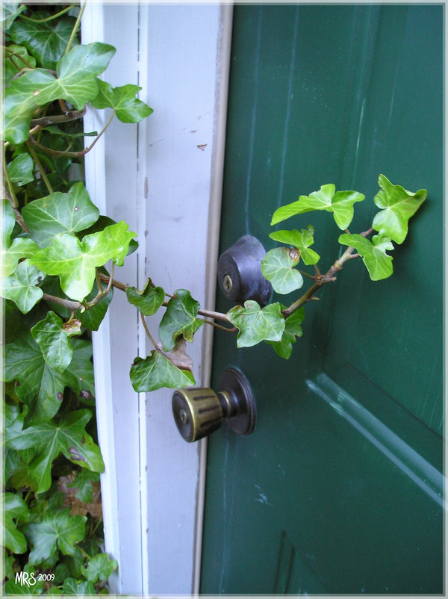

**Madison Elementary staff will be in your neighborhood for “porch visits” this Tuesday afternoon to say welcome to an exciting new school year!**

**Don’t worry… we won’t be coming in… just sharing a friendly word on the porch. We hope to see you then!**

**KNOCK! KNOCK!**