MCj01501020000[1]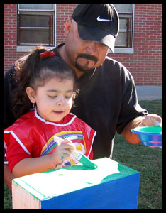[](http://www.usd259.com/default.htm)



**We are looking for two fathers, or male role models, from each classroom to come to school to make a short presentation about what you do at work. (Or you could even just share about your favorite hobby!)**

**We are looking for men to tell our kids how they use math and reading in their jobs. Maybe you measure things. That is MATH. Maybe you read directions. That is READING. We want all students to hear from our Allen men just how important education really is! Can you help us?**

***Aero Dynamic Dads to host “SMART FEST 2009”***

RSVP – Please return this form by Friday, May 8th

Dad or Mentor that will present:_______________________

Student’s Name: __________________________________

Teacher: ________________________________________

I can come to child’s class to talk about: _______________ ________________________________________________

My phone number: ___________________________ _____

I would like an interpreter to help me: YES NO (Circle One)

***Interpreters will be provided if that would be helpful to you when you make your presentation!***

**Allen Elementary School**

**Wednesday, May 13th**

**1:00 p.m. - 2:00 p.m.**

**All Dads meet in the Gym**

**2:00 p.m. – 3:00 p.m.**

**Dads go to classrooms to make presentations**

*Dinner will be served*

