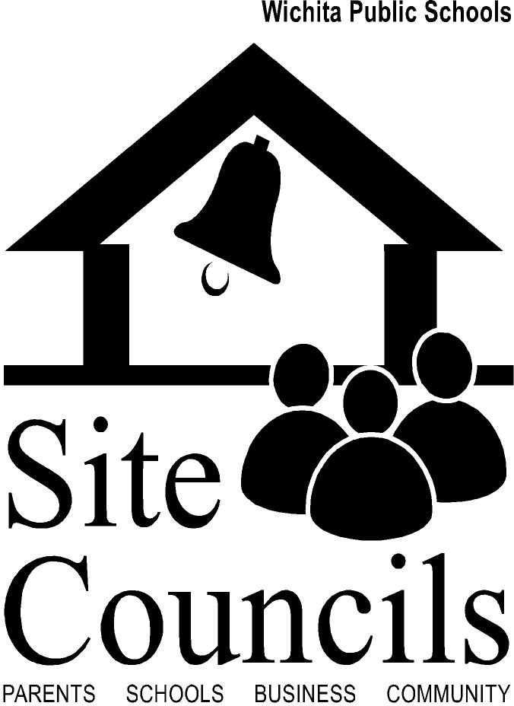
Site Council Survey for Project Options

Best practice research states that when Site Council members focus on areas that are project-oriented, Site Council is more effective. Below is a list of possible focus areas. Please take a few moments to indicate which areas you feel are the most important and of interest to you. The results will be compiled, then utilized to set our agenda for the school year. Thank You!

Examples of Focus Areas…
(Please narrow your selection to three)

- Student Achievement

- Safety

- Attendance

- Family Engagement

- School Building Improvements

- School Budget

- Recruiting and Maintaining Site Council Members

- Behavioral

- Other: ______________________________________________________________

