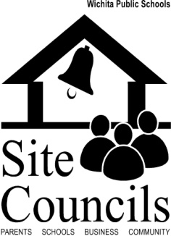

Section I: Introduction to Site Council

Definition: Site Council is an advisory group, mandated by state and district policy, whose purpose is to support the continuous improvement of schools by: capitalizing on opportunities that will improve student performance; promoting a safe and respectful climate for learning; and embracing the community as partners in our work.
Site Council can be an excellent forum for partnering with families and the community for school improvement. Sometimes, however, Site Council is relegated to a simple “sit and get” meeting in which school budget or parking concerns are discussed, but no real recommendations or improvements are made. The Site Council members are not involved in school improvement in any significant way and the meetings simply take place for compliance’s sake.
Goals for this Guide
The aim of this guide is to move Site Council beyond compliance to quality. It will describe how Site Council should be organized, what membership should look like and how Site Council can be evaluated. It will also provide examples and best practices for a variety of projects Site Councils can take on.
Before planning next steps, it is important to first assess the current Site Council. The School Site Council Assessment is a tool that the Family Engagement Team can use to assist in evaluating the current Site Council.

Handout #1 – School Site Council Assessment

