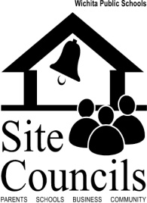
Site Council Member Training

Introduction to Site Council

Definition: Site Council is a advisory group, mandated by state and district policy, whose purpose is to support the continuous improvement of schools by: capitalizing on opportunities that will improve student performance; promoting a safe and respectful climate for learning; and embracing the community as partners in our work.

Site Council is an excellent forum for families, community members, and schools to partner together for school improvement. As a member of site council, you will have the opportunity to:
- Learn about school and district programs and data
- Collaborate with teachers, principals, parents, and community members
- Provide input on school decisions that impact student achievement
- Learn research-based practices that lead to taking a more pro-active approach by becoming more project-focused. Project ideas that have been successful include:
  - Recruit new members during Open House, Parent Teacher Conferences, etc.
  - Research new initiatives that will support the school
  - Assess school safety concerns
- Learn the advantage of using the Planning Cycle to assist in identifying to implementing areas of improvement at the school.

A few facts about Site Council:

- Board Policy states that the Council shall meet at least 4 times a year. Best practices research suggests meeting monthly.
- Should consist of 6-12 members, including parents, business representatives, community members, support staff, teachers, school administrators, and students.
- Members should represent an accurate reflection of the school’s population and the community that it serves.
- The principal should report the names of members to the appropriate superintendent by October 15 of each year.
- The work of the Site Council is advisory only; it makes recommendations, not decisions.

“The Kansas Association of School Boards affirms the key role of Site Councils and is committed to providing quality services to school districts and their site councils as they continue with school improvement efforts.” – A Principal’s Guide for Effective School Site Councils/Kansas Association of School Boards

