Site Council Assessment
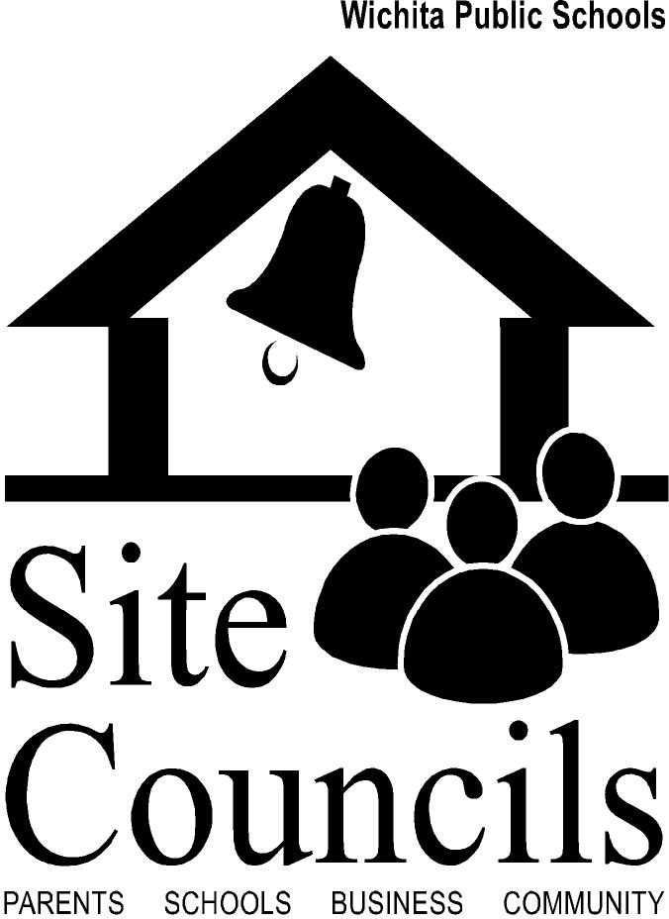

The Family Engagement Team should consider the following questions relating to Site Council. These questions can assist in discussing and evaluating the current Site Council in order to determine its effectiveness and plan next steps.

- Does your school have an active Site Council?

- Does your Site Council reflect your diverse parent/student population?

- Does your Site Council consist of community members?

- Is your Site Council involved in making recommendations that relate to student achievement?

- Is your Site Council involved in making recommendations that relate to family engagement?

- Does your Site Council operate as a part of PTA/PTO or does it operate as a separate entity?

