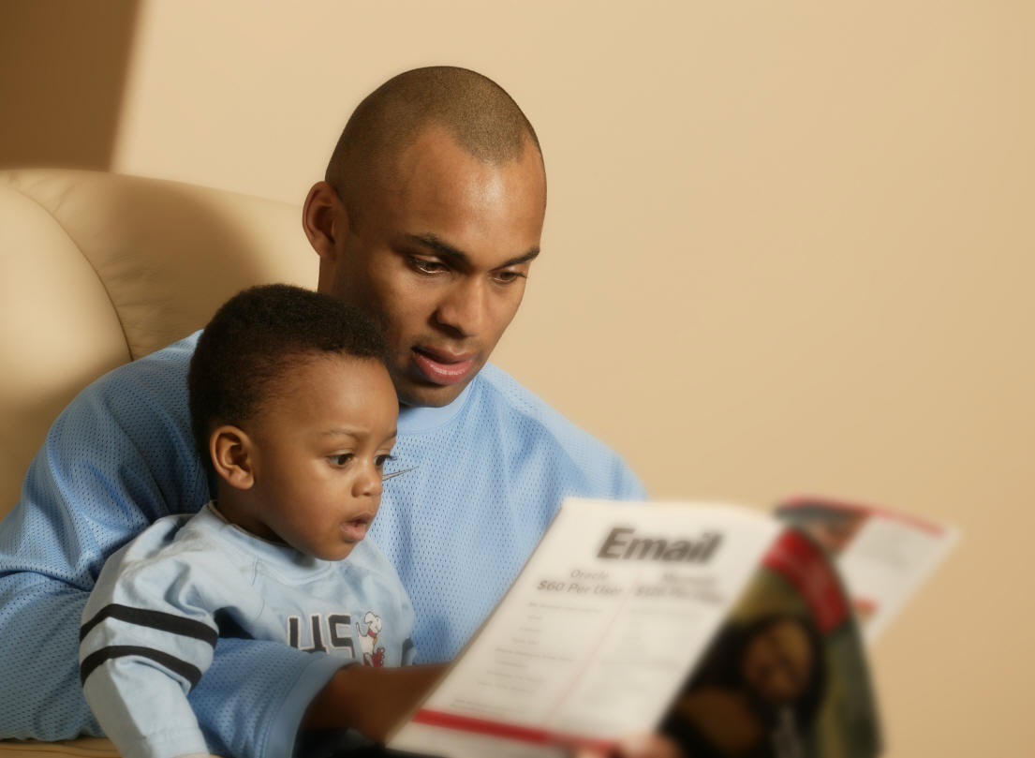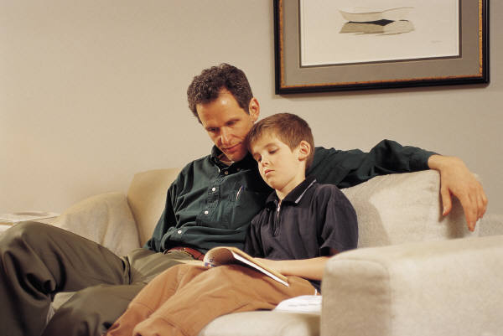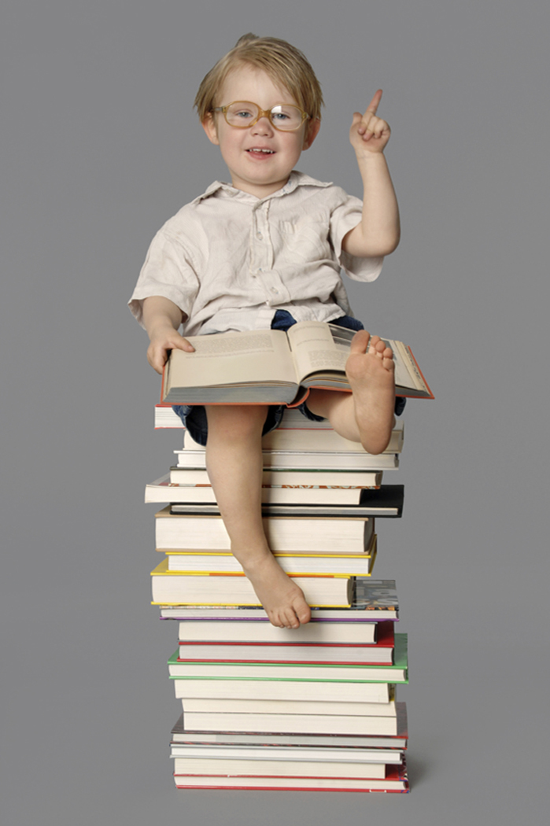

**Only 35% of fathers have ever read a book**

**to their kids. We’re about to change all that!**

*“Read to me, Dad!”*

Calling all Madison

father figures:

Thursday, June 2nd

9:00-11:00 AM

Or

1:00-3:00 Pm

**You may choose to read to just your child, or a group of children. Bring your favorite book or choose one from our library.**

**Please stay and enjoy some refreshments in the library and help your child choose a new book to check out and bring home**

