**okay...now what?**

“Todos los padres son bienvenidos, pero no tendremos ningún intérprete para este evento”.

**Sound familiar?**

This age can be quite a challenge. Help is on the way. Join us for practical ideas & techniques that:

 Are easy to learn

 Create responsible kids

 Change lives

 Start right away

**This class will allow time for open discussion about real life issues**

**that impact your families today.**

**Join us for some laid back**

**conversation about....**

**Surviving Your Child’s Middle School years**

Without losing your cool

or your sense of humor.

**SATURDAY**

**February 27**

**11:00-NOON**

Madison Middle School

Library

Monthly classes will be held on the

last Saturday of each month.

*“That’s not fair!”*

*“All the other kids do it.”*

*“I don’t care.”*

*“You can’t make me!”*

*“Why don’t you trust me?”*

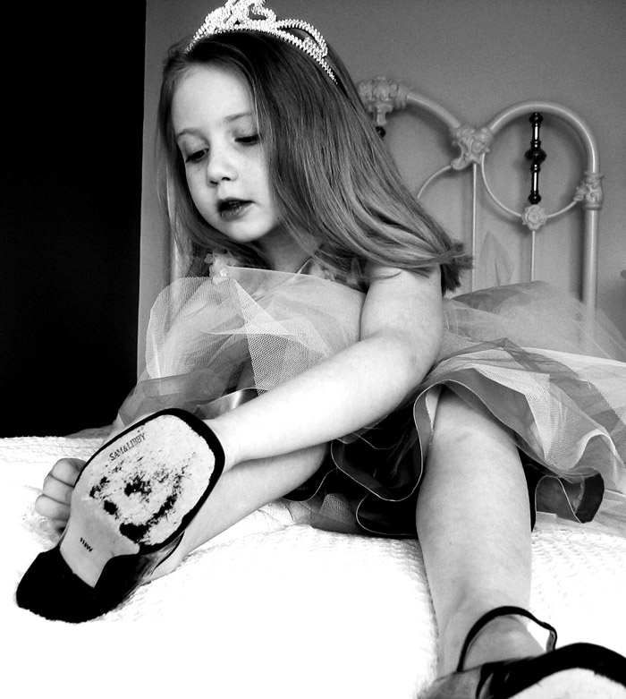

**Remember when you couldn’t wait**

**for them to grow up and act their age?**



FREE!