C:\Documents and Settings\rcook\Local Settings\Temporary Internet Files\Content.IE5\WO9MQ2G8\MC900188107[1].wmf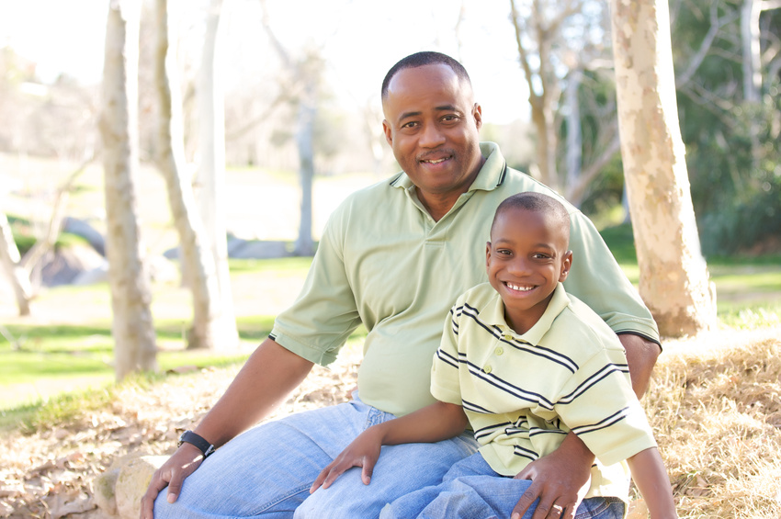MCj04242080000[1]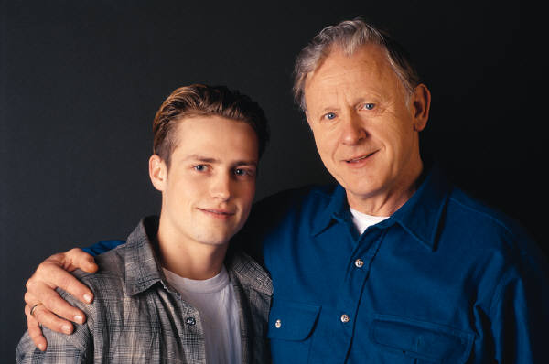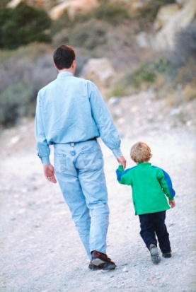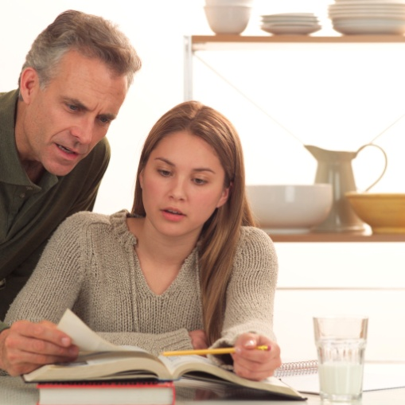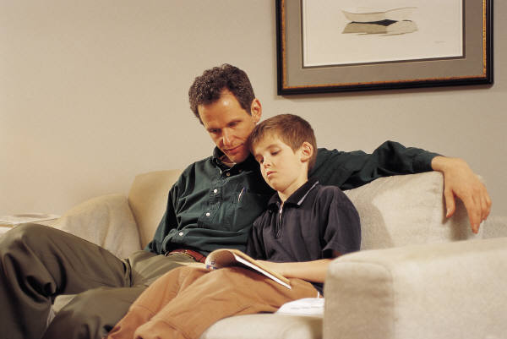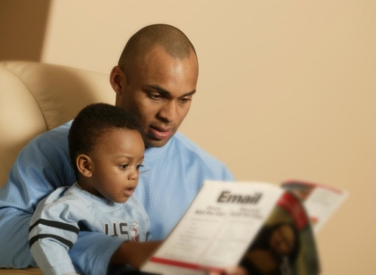

**Attention Madison fathers and father figures …**

WE WANT YOU!!!

Madison Men are ready to join forces and support our children at home and school.

We want you at the table. The only thing you need to bring is your enthusiasm for kids and a willingness to share ideas

and get involved.

For more information,

call Mike Jones at 973-000.

WHY

involve fathers and father figures at Madison?

**When men are actively involved**

**in a child’s education, children:**

◻ **do better in school**

◻ **enjoy school more**

◻ **are less likely to repeat a grade**

◻ **are able to make better choices**

◻ **have better attendance**

◻ **are more likely to graduate high school and attend college**

◻ **exhibit better behavior and values**

◻ **are better equipped to resist peer pressure**

**PLEASE COMPLETE AND RETURN THIS FORM TO YOUR CHILD’S TEACHER. Thanks!**

**___ Yes, I am interested. Please call me.**

_________________________________________________  
Name

_________________________________________________  
Student

_________________________________________________  
Phone

_________________________________________________  
Email

Madison is looking for a few good men.

MAN



P WER

*Harness one of the most powerful*

*Influences on our children and their*

*future... dads and other father figures.*

