C:\Documents and Settings\rcook\Local Settings\Temporary Internet Files\Content.IE5\WO9MQ2G8\MC900188107[1].wmf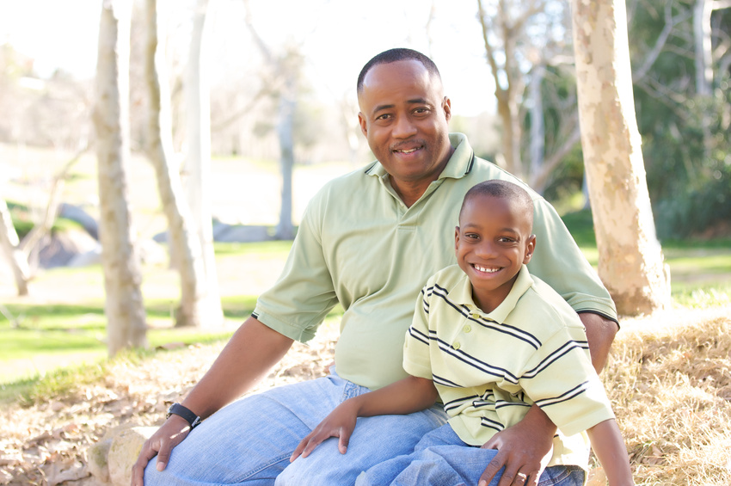MCj04242080000[1]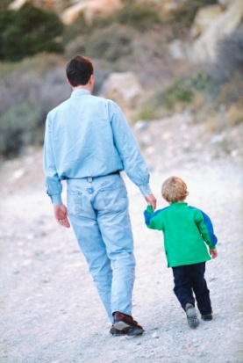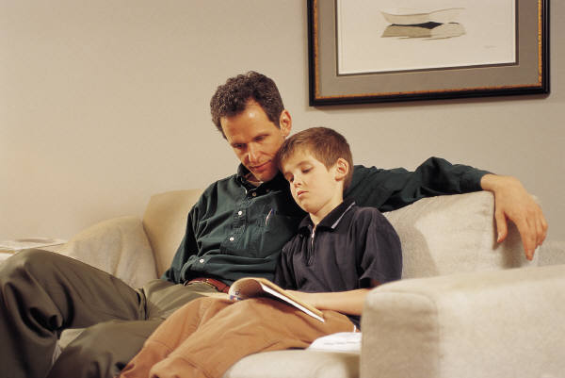

Please return the completed form to your child’s teacher.

___ YES! I want to be part of the Madison Men group. ______________________________________________  
 Name

___ YES! I plan to attend the Sept. 3rd meeting. ______________________________________________  
 Student Name

___ I cannot attend, but would like to be involved. ______________________________________________  
 Phone

WHY

Why involve fathers and father figures at Madison?

**When men are actively involved**

**in a child’s education, children:**

◻ **do better in school**

◻ **enjoy school more**

◻ **are less likely to repeat a grade**

◻ **are able to make better choices**

◻ **have better attendance**

◻ **are more likely to graduate high school and attend college**

◻ **exhibit better behavior and values**

◻ **are better equipped to resist peer pressure**

Madison Men are looking for ways to join forces and support our children at home and school.

We want you at the table. The only thing you need to bring is your enthusiasm for kids and a willingness to share ideas.

Tuesday, September 3

6:30-7:30

Mead Library

For more information,

call Mike Jones at 973-000.

Madison is looking for a few good men.

MAN



P WER

*Harness one of the most powerful*

*Influences on our children and their*

*future... dads and other father figures.*

