Madison PTA Presents

Family Movie Night

Friday,

November 7

Madison Gym

Doors & Concessions Open

6:00 p.m.

Show Time

6:30 p.m.

Please bring blankets and lawn chairs

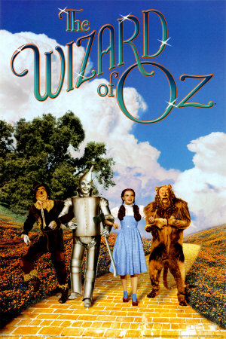

**CONCESSIONS:**

Hot Dog $1.00

         w/chili or cheese $1.50

         w/chili and cheese $2.00

Nachos  $1.00

Popcorn $ .50

Chips $ .50

Pickle $ .50

Sugar Cookie $ .50

Candy $ .75

Pop / Water  $1.00

$

PARENTS MUST ATTEND WITH STUDENTS!

