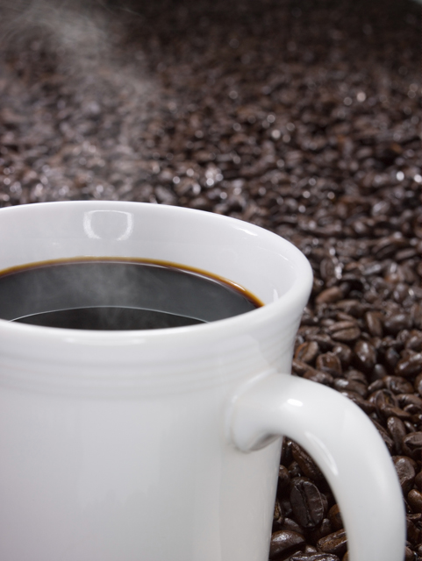

**Let’s talk**

**WHAT MONTHLY COFFEE WITH THE PRINCIPAL**

**WHEN Tuesday, September 3 – 8:30 AM**

**WHERE Madison Library**

**WHY Open Discussion and upcoming events or news  
 Hot Topic: Uniforms (pros and cons)**