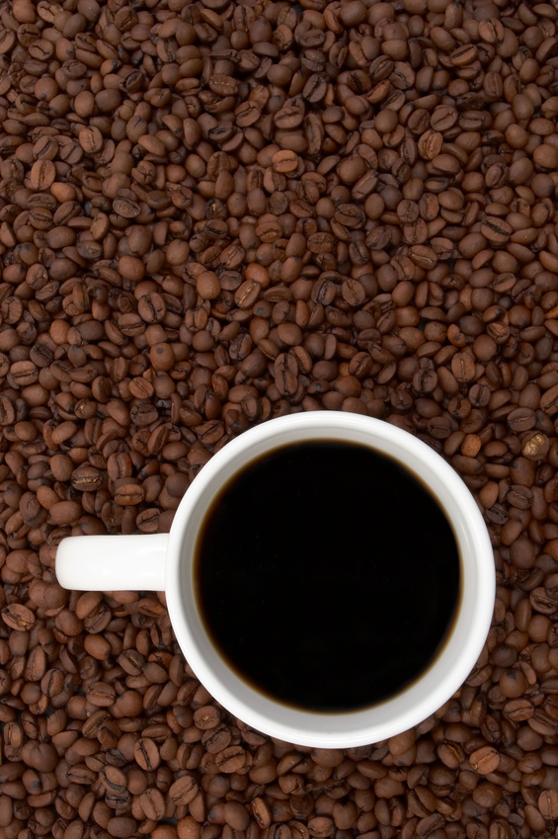

Let’s talk

**WHAT MONTHLY COFFEE WITH THE PRINCIPAL**

**WHEN Tuesday, September 3, 8:30 AM**

**WHERE Madison Library**

**WHY Open Discussion and upcoming events or news**

**This month we will talk about uniforms   
(pros and cons)**