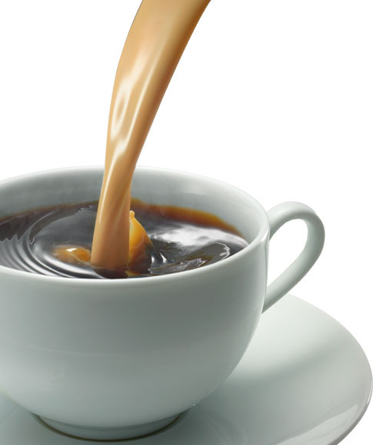

**Madison staff will be serving up some coffee and some love…**

**Tuesday morning as you drop your child off for school.**

**See you bright and early at the curb.**

**Leave room for one more cup!**

**Thanks to Starbucks, our wonderful partner!**

Coming soon   
to a curb   
near you!

**Coming soon  
to a curb near you…**