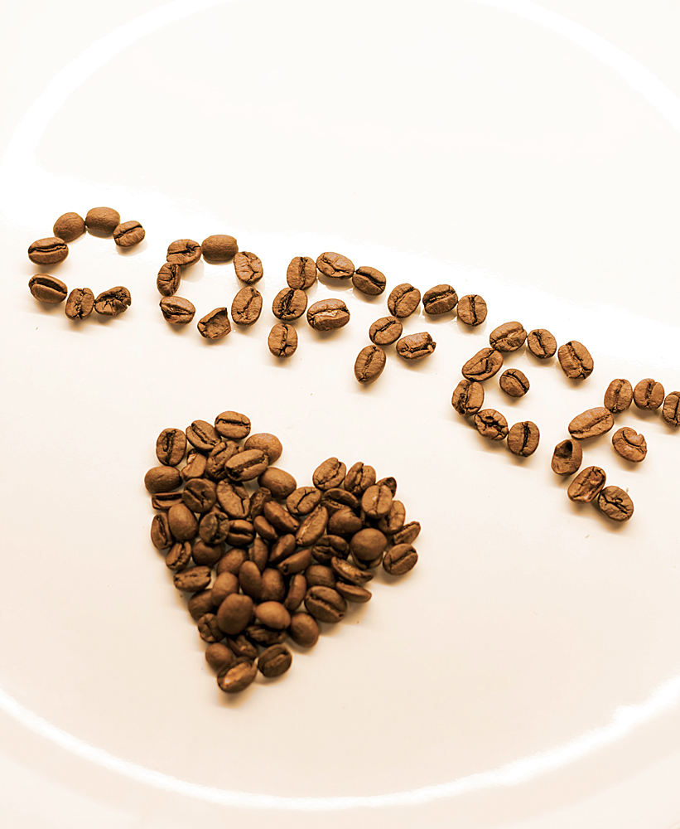

**Madison staff will be serving up**

**some coffee and some love…**

**Tuesday morning as you drop**

**your child off for school.**

**See you bright and early at the curb. Leave room for one more cup!**

**Thanks to Starbucks, our wonderful partner!**

**Coming soon  
to a curb near you…**