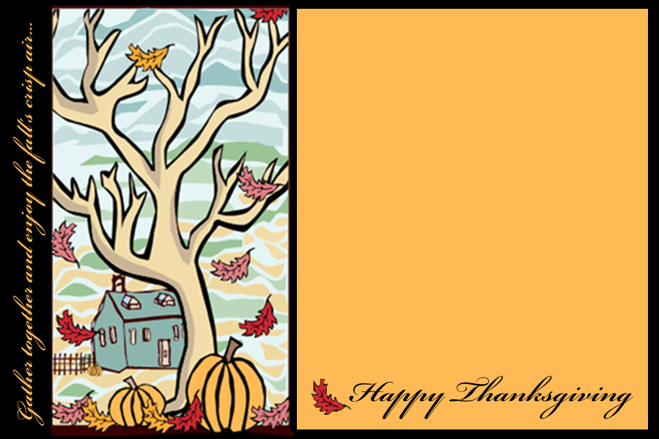
The staff at Madison Elementary Invites you to join us for

“Coffee and Cocoa
At The Curb”

Tuesday, November 17th outside our building from 8:30-9:00 a.m.

There’s no charge…just a warm hello!

