

meeting topic

“BUDGET DECISION MAKING”

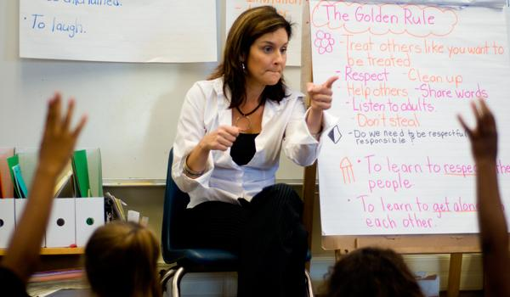

**Tuesday, March 9th**

**4:30 pm - 5:30 pm**

**In the Library**

**Refreshment provided**

**Interpreters and childcare will be available**

Madison Elementary Site Council

**Share your view and let your voice be heard!**

We would like to invite all Madison families and community members to come and participate in our upcoming Site Council meeting discussion on the budget and how it affects our school and students. Please make plans to join us. Your participation is needed and appreciated.

**You’re**

**Invited!**