Welcome to Our Family!
  - Brooks Technology and Fine Arts Middle Magnet School
Future 6th Grade Family Open House and Enrollment Night
Tuesday, May 11, 2010
5:45 – 6:30 p.m.
Welcome Reception
Experience the Fine Arts and Tour the 6th grade wing.
Dinner available for $2.50 per person until 6:20 p.m.: Hotdog, chips and drink. Other snacks are available.
Proceeds benefit the Leadership program.
Learn about Parent Involvement Opportunities
6:30 – 7:00 p.m.
Welcome Program
Get to know Brooks, its staff and learn about
what you have to look forward to.
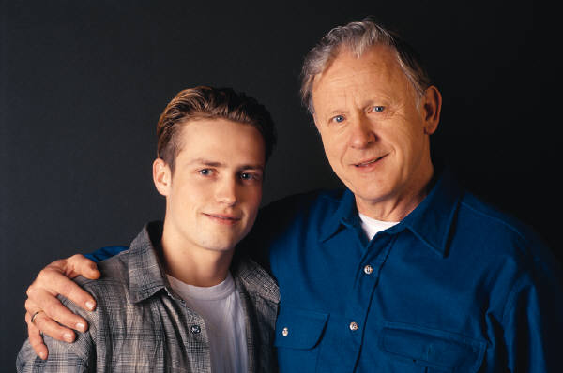
7:00- 8:00 p.m.
Enrollment
Student and parents enroll for 6th grade classes.
The counselor and 6th grade team will be available to assist in completion of forms.

Performing Arts
Choir - Drama - Orchestra - Band
Many brooks students are involved in the performing arts at Books Middle School. The newest addition to the performing arts department is drama. From band to orchestra to choir to drama, students have the opportunity to use their abilities and talents to become part of talented groups.
Students enrolled in these classes are expected to participate in activities after school hours. Whether concerts or other performances, parents and fellow students have the opportunity to watch these students perform and support the very talented students of Brooks Middle School.
This year was the first time in many years for Brooks Students to perform a musical. Many students were involved, making the show a huge success.
Student Technology Leadership
STL is a program allowing students to work with technology, resolve problems, and assist students and teachers. STL's attend workshops and compete with other students in competitions. When teachers and students need help with technology, STL's provide help.
STL's can assist with simple things such as building a table on Microsoft Word to more complex things like Flash and Dreamweaver to make websites or videos. They also are certified in many programs including Microsoft Office, Macromedia, Inspiration, iMovie, GarageBand, and many more. Being a technology magnet, Brooks is always working to find ways to integrate technology into each day and in each class at Brooks. Taking tests online, making projects or overseeing laptops, students and teachers both are finding ways to integrate technology to make things easier, more efficient, and better for everyone.
We are a Cross-Platform school. Featuring four full PC labs, 7 PC laptop carts, a mini Mac-Centered Lab, and a Mac laptop cart, we are integrating in the best of both platforms. Brooks also has access to the wireless network throughout the building, allowing students and staff access to the internet and the servers throughout the building.
Leadership
The Brooks Leadership Program is one of the best Leadership programs in the city. Brooks Leadership program is the only Marine Corps Leadership program in the city and is very deep with tradition. The Brooks Leadership program is not only known for their unique uniforms, but is also known for their outstanding drill teams and the discipline displayed on the drill floor. The Brooks Leadership program demonstrated their strong knowledge skills last year by beating the defending champs in Leadership Academic Tournament (LAT) which is like NAL or Scholars bowl. Brooks Leadership program is also very active in community service with over 4300 hours completed in one school year last year. Cadets work at events and organizations like, Toys for Tots, American Cancer Society, Cowtown, Cystic Fibrosis, Bread of Life, River Fest, Air Shows and many Color Guards. The Brooks Leadership Cadets and Instructors expect nothing less than the best and this is why we have much success!

