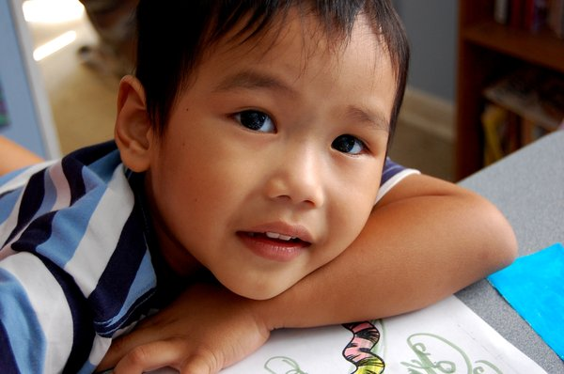

Kindergarten Families
You are invited to our
 | Boo Hoo | Breakfast
Please join us in the library after dropping your newest little student off in their classroom on the first day of school.
Monday, August 16, 2010
9:10 to 10 a.m.
Sunny Elementary

Don’t miss this chance to meet parents of your
child’s future friends, meet the assistant principal,
ask questions and learn more about our PTO (parent organization).

