Madison Elementary presents:

Basic BIST Hour

(Behavior Intervention Support Team)

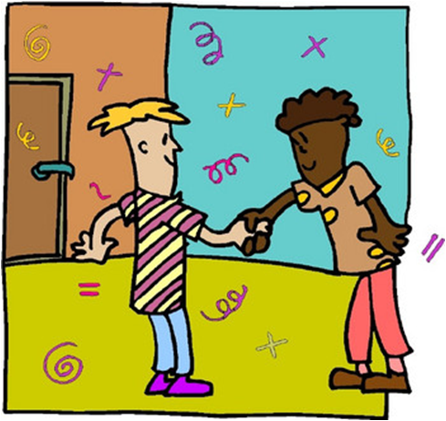

Join us…

Thursday, Oct. 23rd

From 3-4 p.m.

Madison Elementary Room D7

Childcare

Provided

Refreshments Served

• What is BIST?

• What do all the terms mean?

• Can I use BIST at home?

• How is BIST used in the classroom?

• Why does Madison use BIST?